**VISVESVARAYA TECHNOLOGICAL UNIVERSITY Jnana Sangama, Belgagavi – 590 014**



**A Computer Graphics Project Report On**

**“VIDEO PLAYER”**

**Submitted in Partial fulfillment of the Requirements for the VI Semester of the Degree of**

**Bachelor of Engineering**

**In**

**Computer Science & Engineering**

**By**

**MOHAMMED ISMAIL (4MW18CS042)**

**POOJARI HARSHIT SADASHIV (4MW18CS050)**

**Under the Guidance of**

**Mrs SOWMYA S**

**Asst. Prof, Dept. of CSE**



**DEPARTMENT OF COMPUTER SCIENCE AND ENGINEERING Shri Madhwa Vadiraja Institute of Technology & Management Vishwothama Nagar, Bantakal-574115**

**Aug,2021**

**SHRI MADHWA VADIRAJA**

**INSTITUTE OF TECHNOLOGY AND MANAGEMENT** (A Unit of Shri Sode Vadiraja Mutt Education Trust ®, Udupi)

**Vishwothama Nagar, BANTAKAL – 574 115, Udupi District, Karnataka, INDIA**

**DEPARTMENT OF COMPUTER SCIENCE AND ENGINEERING**



**CERTIFICATE**

Certified that the Computer Graphics Project work entitled **“VIDEO PLAYER”** has been carried out by **MOHAMMED ISMAIL(4MW18CS042) and POOJARY HARSHIT SADASHIV (4MW18CS050)** respectively bonafide student of Shri Madhwa Vadiraja Institute of Technology and Management in partial fulfillment for the award of **Bachelor of Engineering in Computer Science and Engineering** of the Visvesvaraya Technological University, Belgaum during the year **2019-2020**. It is certified that all corrections/suggestions indicated for Internal Assessment have been incorporated in the Report deposited in the departmental library. The Graphics Project Report has been approved as it satisfies the academic requirements in respect of project work prescribed for the said Degree.

**Mrs. SOWMYA S Dr. NAGARAJ BHAT** Project Guide, Professor and Head Dept. of CSE Dept. of CSE

External Viva

Name of the examiners 1

2.

Signature with date

**ACKNOWLEDGEMENT**

It is our duty to acknowledge the help rendered to us by various persons in completing this Computer Graphics Project titled “Video Player”

We would like to express our heartfelt thanks to **Dr. Thirumaleshwara Bhat, Principal, SMVITM, Bantakal,** for extending his support.

We would also like to express our deepest gratitude to **Dr. Nagaraj Bhat, HOD, Computer Science and Engineering** whose guidance and support was truly invaluable in completing this project on time**.**

It is our privilege to express our sincerest regards to our project coordinator, **Ms. Sowmya S**, for her valuable inputs, guidance, encouragement and whole-hearted cooperation throughout the duration of our project.

We take this opportunity to thank all our teaching and non-teaching staff of Department of CSE who has directly or indirectly helped the completion of our project.

We pay our respects and love to our parents and all other family members and friends for their love and encouragement throughout our student life.

Thanking you all,

Mohammed Ismail

Poojari Harshit Sadhashiv

ii

**ABSTRACT**

Computers have become a powerful medium for the rapid and economical production of pictures. Mobile app development is a relatively new phenomenon that is increasing rapidly due to the ubiquity and popularity of smartphones among end-users. The goal of our study is to gain an understanding of the main challenges developers face in practice when they build apps for different mobile devices.

The objective of this application is to read and display the video files present in the device in an efficient and intuitive format for user-friendliness. Mobile phones do come with a pre-installed video player but they are very basic and do not contain various features for ease of use. Video files come in various forms of encoding and the basic video player only run a selected few widely used file format. This project has been created for solving a variety of these problems.

i

**TABLE OF CONTENTS**

**CHAPTERS PAGENO** 1. INTRODUCTION 1 2. REQUIREMENT ANALYSIS 3 3. DESIGN 4 4. IMPLEMENTATION 5 5. SNAP SHOT 9 CONCLUSION 11

BIBLOGRAPHY 12 APPENDIX: User Guide 13

iii

*Video Player*

**Chapter1**

**INTRODUCTION**

**1.1 About Android Studio**

Android Studio is the official Integrated Development Environment (IDE) for Android app development, based on IntelliJ idea. On top of IntelliJ's powerful code editor and developer tools, Android Studio offers even more features that enhance your productivity when building Android apps, such as A flexible Gradle-based build system, A fast and feature-rich emulator, A unified environment where you can develop for all Android devices, Apply Changes to push code and resource changes to your running app without restarting your app, code templates and GitHub integration to help you build common app features and import sample code, Extensive testing tools and frameworks, Lint tools to catch performance, usability, version compatibility, and other problems, C++ and NDK support, Built-in support for Google cloud platform, making it easy to integrate Google Cloud Messaging and App Engine.

Creation of software intended to run on mobile devices and optimized to take advantage of those products’ unique features and hardware. Android Studio supports all the same programming languages of IntelliJ (and CLion) e.g. Java, C++, and more with extensions, such as Go and Android Studio 3.0 or later supports Kotlin and all Java 7 language features and a subset of Java 8 language features that vary by platform version. External projects backport some Java 9 features. While IntelliJ states that Android Studio supports all released Java versions, and Java 12, it's not clear to what level Android Studio supports Java versions up to Java 12 (the documentation mentions partial Java 8 support). At least some new language features up to Java 12 are usable in Android.

**1.2 About Video player application**

Creation of software intended to run on mobile devices and optimized to take advantage of those products' unique features and hardware. A typical video player always displays its controls and video content while it's running it can't operate in the background or without a UI. Therefore, it's appropriate to build your app as a single activity containing the UI, a player, a media session, and a media controller.

*Dept of CSE, SMVITM Page 1*

*Video Player*

Video Player is android application that can play various video files. To make use of android OS with more public interest and make it more users friendly so all can use it. This project is to design and implement platform independent media player which can play most of the video files.

**1.3 Objectives**

The objective of this application is to read and display the video files present in the device in an efficient and intuitive format for user-friendliness. Mobile phones do come with a pre-installed video player but they are very basic and do not contain various features for ease of use. Video files come in various forms of encoding and the basic video player only run a selected few widely used file format. This project has been created for solving a variety of these problems.

*Dept of CSE, SMVITM Page 2*

*Video Player*

**Chapter 3**

**REQUIREMENT ANALYSIS**

**2.1 Software Requirements**

฀ Programming Platform JDK 1.7, Android SDK

฀ IDE STS (Spring Tool Suite)

฀ Web server Google Server (Google App Search Engine) ฀ Database Google Database

**2.2 Hardware Requirements**

฀ Microsoft Windows 7/8/10 (32 or 64 bit).

฀ Mac OS X 10.8. … Ubuntu or Fedora or GNU/Linux Debian. ฀ Memory 2GB RAM. 4GB RAM recommended.

฀ 500 MB disk space.

฀ 1 GB for Android SDK.

฀ Java Development Kit (JDK) 7.

*Dept of CSE, SMVITM Page 3*

*Video Player*

**Chapter4**

**DESIGN**

The basic requirements include the hardware and software requirements, keyboard key are suitably implemented to provide an interactive interface to the user by which the user can select the part required to operate on, which are then executed on the standard output device, the monitor. User interaction is provided through keyboard. The basic concepts of project development such as menus, display, and much more functions, functions are implemented to design the source code. The project is very presentable and thus easy to understand.

**Flow chart**

Data flow design is as shown below- covering the flow of the data in the system. It describes the relation between user input and the system behavior.

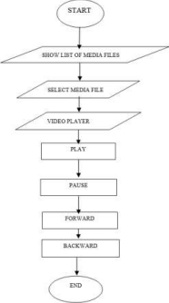

**Flow chart for video player**

*Dept of CSE, SMVITM Page 4*

*Video Player*

**Chapter4**

**IMPLEMENTATION**

*Dept of CSE, SMVITM Page 5*

*Video Player*

**Chapter 5**

**SNAPSHOTS**

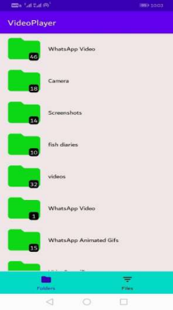

This is the interface of our app. Here we can see the various videos stored in different files.

*Dept of CSE, SMVITM Page 6*

*Video Player*

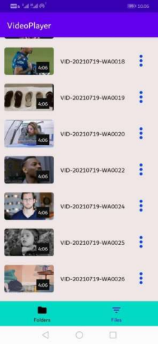

Here we can see all the videos in a single page.

*Dept of CSE, SMVITM Page 7*

*Video Player*

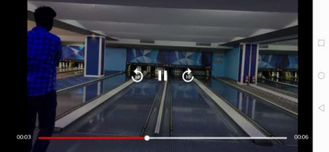

In this window we can play the video and can be made 10 second forward or backward. 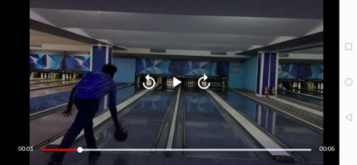We can pause the video by clicking on pause button as shown above.

*Dept of CSE, SMVITM Page 8*

*Video Player*

**Chapter6**

**CONCLUSION AND FUTURE ENHANCEMENTS**

The development of the project is not an easy process as it involves a lot of challenges in different stages of software analysis, design, coding, and testing. Having understood the requirements properly and implementing the solutions as per the expectation brought the closure of the project. We have tried our best to make this project very realistic so that the user does not face any trouble when switching over from any real-life android project to this highly useful one.

**6.1 SCOPE FOR FUTURE ENCHANCEMENTS**

The following additional work can be performed on our project.

∙ It can be made more user interactive.

∙ Future enhancement can be done by adding audio player

∙ We can add the editing features for the video.

*Dept of CSE, SMVITM Page 9*

*Video Player*

**Chapter 7**

**BIBLIOGRAPHY**

1. Android Developers https//developer.android.com

2. GeeksforGeeks https//www.geeksforgeeks.org/complete-guide-on how-to-build a-video-player-in-android/

3. https//en.wikipedia.org/wiki/Media_player_software

*Dept of CSE, SMVITM Page 10*

*Video Player*

**User Guide**

In order to use this simple app here is the manual.

⮚ Our program is mainly concerned with the design and demonstration of video player.

⮚ When we open the app, we can see different files in which the videos are stored.

⮚ Select any video to play.

⮚ It contains,

1. Play button

2. Pause button

3. Forward button

4. Backward button

*Dept of CSE, SMVITM Page 11*